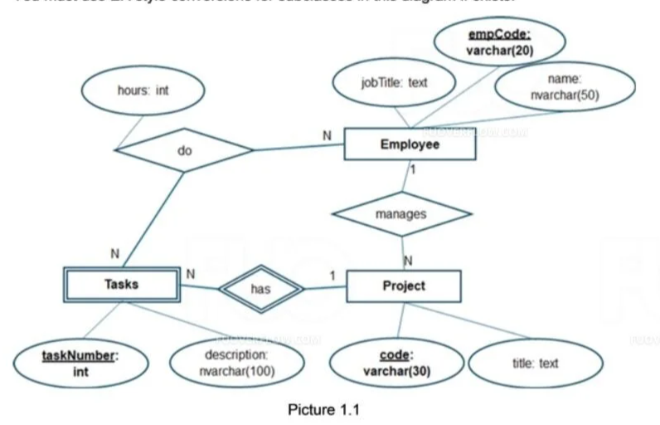

CREATE TABLE Employee (

empCode VARCHAR(20) PRIMARY KEY,

name NVARCHAR(50),

jobTitle TEXT

);

CREATE TABLE Project (

code VARCHAR(30) PRIMARY KEY,

title TEXT,

managerEmpCode VARCHAR(20),

FOREIGN KEY (managerEmpCode) REFERENCES Employee(empCode)

);

CREATE TABLE Tasks (

taskNumber INT PRIMARY KEY,

description NVARCHAR(100),

projectCode VARCHAR(30),

FOREIGN KEY (projectCode) REFERENCES Project(code)

);

CREATE TABLE Employee_Task (

empCode VARCHAR(20),

taskNumber INT,

hours INT,

PRIMARY KEY (empCode, taskNumber),

FOREIGN KEY (empCode) REFERENCES Employee(empCode),

FOREIGN KEY (taskNumber) REFERENCES Tasks(taskNumber)

);